# Before we start you should:

* Have SSH enabled on your local computer
* A CS account

# 1. Find your SSH config file

This config file is a text file that is used to manage known remote machines. It is usually located at:

Windows: C:\Users\{your_username}/.ssh/config

Mac/Linux: ~/.ssh/config

If the config file or the .ssh folder does not exist, simply create them.

# 2. Add csportal to config file

Change accordingly the following content and add it to your config file (csportal to your choice of alias and py5yy to your computing ID):

Host csportal

HostName portal.cs.virginia.edu

User py5yy

Testing:

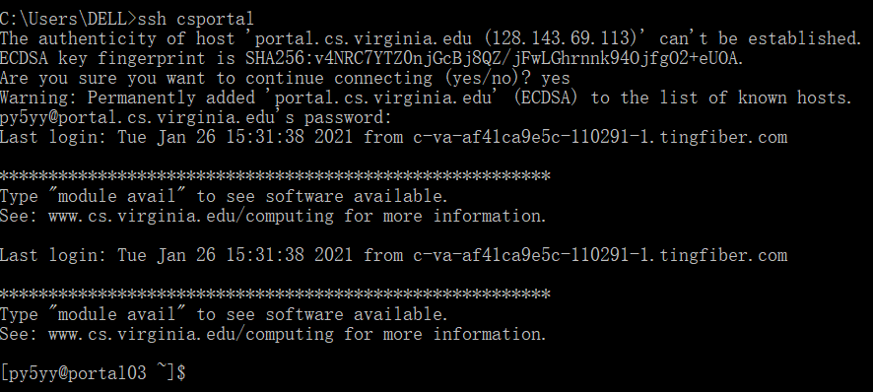

# 3. Add lab servers (labsrv06 and granger1) to config file

Change accordingly the following content and add it to your config file (py5yy to your computing ID and csportal to your alias for portal.cs.virginia.edu):

Host granger1

HostName granger1

User py5yy

ProxyCommand ssh -q -W %h:%p csportal

Host labsrv06

HostName labsrv06

User py5yy

ProxyCommand ssh -q -W %h:%p csportal

The csportal/portal01-04 is like a gate and we need to first go to a csportal server before going further to our lab server. To avoid typing ssh commands twice, we are using the ProxyCommand to make a jump from csportal to our lab server.

For Windows users - If you get a “CreateProcessW failed error:2 posix_spawn: No such file or directory” failure, replace the ProxyCommand lines with: ([See details](https://serverfault.com/a/988253)):

ProxyCommand C:\Windows\System32\OpenSSH\ssh.exe -q -W %h:%p csportal

# 4. Add public key to remote servers

Doing so allows us to log into a remote server without having to explicitly type in our password.

1. (skip this step if you did it before) Generate a pair of authentication keys on your local computer. Do not enter a passphrase.

> ssh-keygen -t rsa

2. Add the public key of your local computer to csportal

> scp C:\Users\DELL/.ssh/id_rsa.pub py5yy@csportal:~/

> ssh csportal

[py5yy@portal03 ~]$ cat id_rsa.pub >> .ssh/authorized_keys

3. Add the public key of your local computer to granger1

> scp C:\Users\DELL/.ssh/id_rsa.pub py5yy@granger1:~/

> ssh granger1

[py5yy@granger1 ~]$ cat id_rsa.pub >> .ssh/authorized_keys

You can now log into granger1 without explicitly going through csportal or typing your passwords:

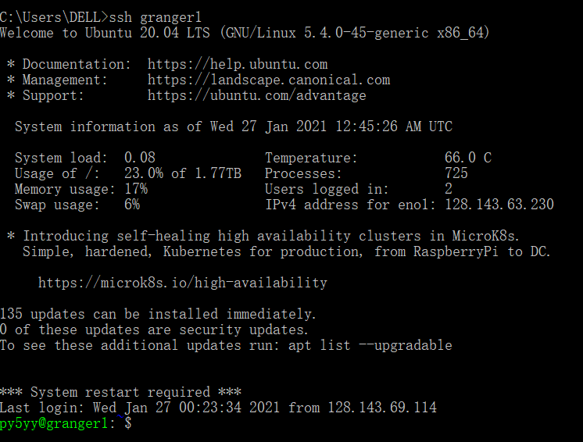

# 5. Connect to remote servers from VSCode

### Step 0: Install [Visual Studio Code](https://code.visualstudio.com/) on your local machine

### Step 1: Install the ssh extensions

VSCode itself is just a lightweight text editor and is empowered by various extensions. In the extension tab on the left, search for the **Remote - SSH**extension and install it.

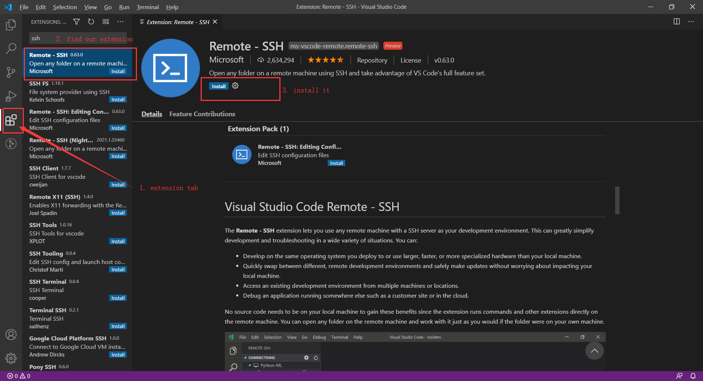

### Step 2: Tell VSCode where your ssh config file is

Usually VSCode is smart enough to detect our config file. Just in case it didn’t or got it wrong or you used a custom config file:

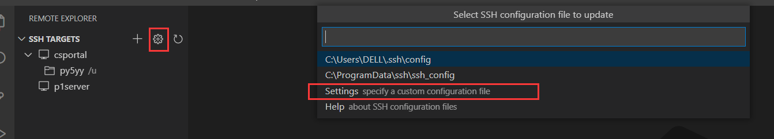

### Step 3: SSH to remote machines

In the Remote Explorer tab, select the remote server you want to ssh to (csportal), a new window will open:

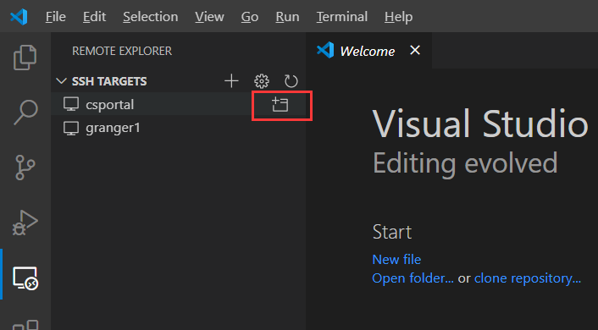

In the new window, to see our directory, select open folder→select a directory→OK.

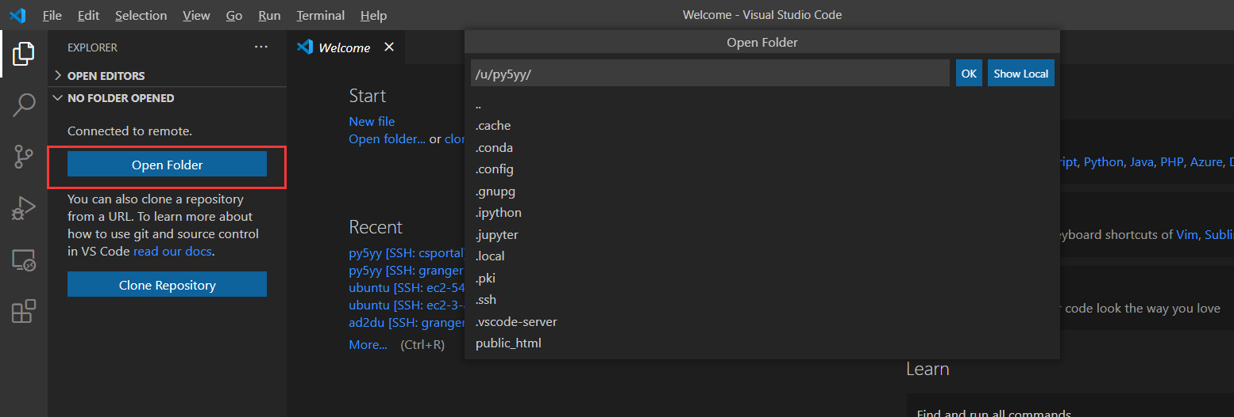

The window will reload and give you the view of the directory. You can click on files to edit them, and create new folders/files by right clicking.

To run commands in a terminal, click the plus button to open one:

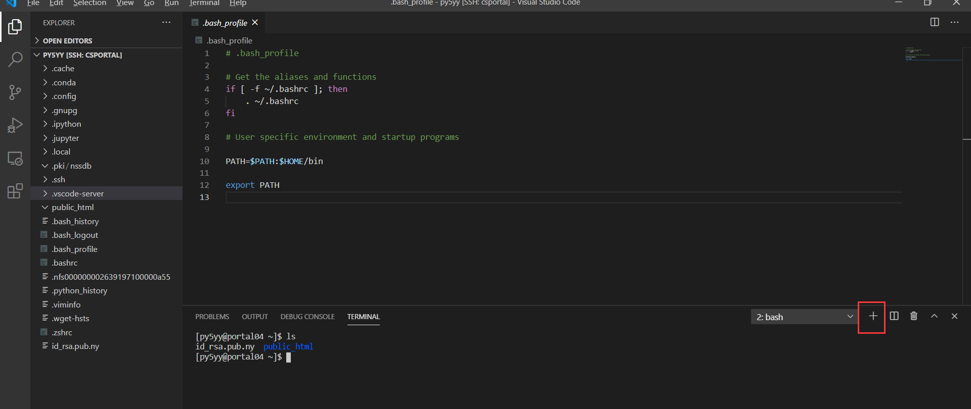

Next time you want to access this folder, you can just click it directly to connect to the remote host:

